Weed Management in Integrated Rice + Fish + Poultry Farming System



Sponsored by,
Indian Council of Agricultural Research (ICAR)

Project duration: 2002 – 2005
Project Outlay: Rs.11.15 lakhs

Objectives
- To study the contribution of herbivorous fish species in rice weed management.
- To study the impact of poultry waste on weed management in rice.
- To study the impact of rice weed control measures viz., herbicides and azolla culture on component enterprises like fish and poultry.
- To evolve a wholistic weed management for rice + fish + poultry farming system.

OUTPUT
Regarding the contribution of fish in rice weed control, all the three fish species viz., Grass Carp, Common Carp and Tilapia were observed to feed on all the three major weed types viz., grasses, sedges and broad leaf weeds with almost equal preferences (biomass reduction with grass carp being 33.17 per cent in Echinochloa sp., 31.82 per cent in Cyperus rotundus and 28.75 per cent in Eclipta alba. However, grass carp was observed to be a more voracious feeder than Tilapia and Common Carp. Polyculture involving grass carp reduced the weed biomass better than monoculture with Tilapia and Common Carp.
Poultry manure was also observed to compliment weed control in rice by virtue of inhibiting weed seed germination. Poultry manure worked out at normal voiding rate (7.8 g/day) as well as at the least standard comparison concentration of 1 per cent inhibited germination of E.crusgalli and paddy significantly.
Micro plot experiments also confirmed that different voiding rates of poultry manure alone and along with herbicide butachlor suppressed weed growth and competition significantly. Poultry manure @ 15.6 g /day along with butachlor recorded the least weed counts of 39.51 m⁻² at 30 DAT and 46.99 m⁻² at 60 DAT and also individual weed species count at 60 DAT. This treatment was on par with normal voiding rate of poultry manure @7.8 g/day along with herbicide)
Application of double the voiding rate of poultry manure along with butachlor showed least weed DMP of 490.72 kg ha⁻¹ and the highest weed control index of 54.98 which was on par with normal voiding rate of poultry manure along with butachlor application.
The growth attributes (plant height, number of tillers hill⁻¹, crop DMP and LAI) yield attributes (No. of panicles hill⁻¹ and No. of grains panicle⁻¹) and grain yield of rice and straw were significantly influenced by the application of poultry manure along with herbicide.
In the Institutional field experiment, different weed control treatments viz., unweeded control, hand weeded twice, pressmud @ 10 t ha⁻¹ + azolla @ 1 t ha⁻¹, butachlor @ 1.5 kg ha⁻¹, anilophos @ 0.75 kg ha⁻¹ and oxyfluorfen @ 0.25 kg ha⁻¹ were tried in the rice + fish + poultry system. application of oxyfluorfen @ 0.25 kg ha⁻¹ (T₆) recorded the least weed counts of 7.21m⁻² at 30 DAT and 10.83m⁻² at 60 DAT and also individual weed species count at 60 DAT.
Conclusion
The research out put from this AP cess fund Research Project gives evidence for the contribution of fish as a farming element or component in transplanted rice towards weed management. All the three species of fish viz., Ctenopharyngodon idella (grass carp), Oreochromis mossambicus (tilapia sp) and Cyperinus carpio (common carp) are feeding on all the three different weeds viz., grasses, sedges and broad leaf weeds. However, grass carp is observed to be more voracious feeder on all the three different types of weeds. The same could serve better individually or as a component of fish polyculture for complementing weed control in transplanted rice. The sustainable weed control could be further enhanced by integrating poultry component as the poultry voidings show significant weed suppressing ability without affecting transplanted rice, when integrated @ 1 bird for every 8 m² area of rice. In this integrated rice + fish + poultry farming systems, better weed management and economics could be obtained from application of herbicides like oxufluorfen without any mortality on fish component. However, herbicides are observed to cause tissue deformations in fingerlings.
Photos
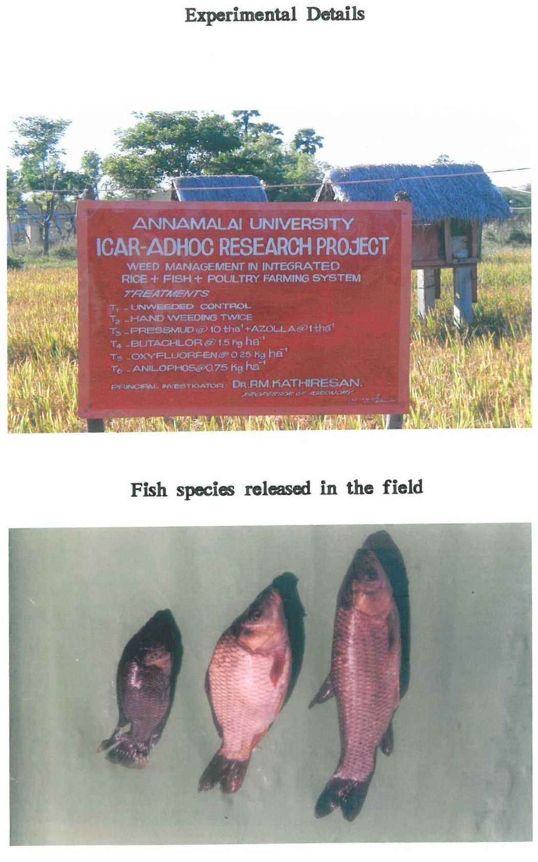
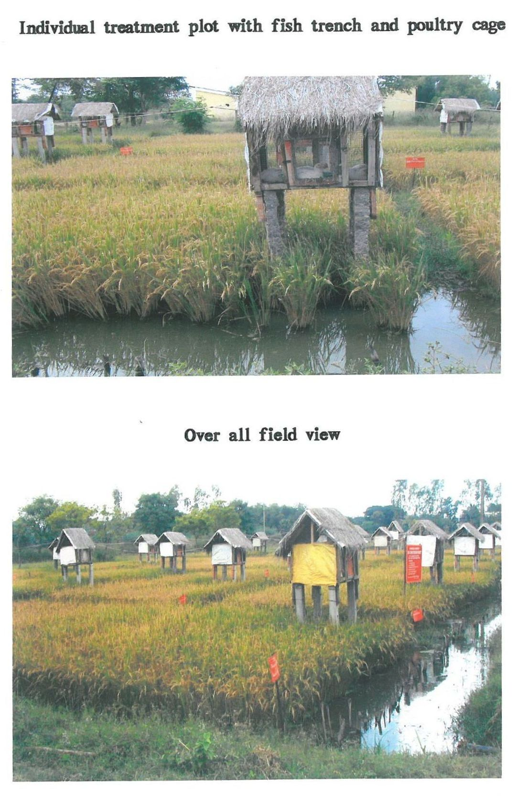
Double
Control

